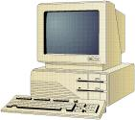

ICT1
Information Communication Technology
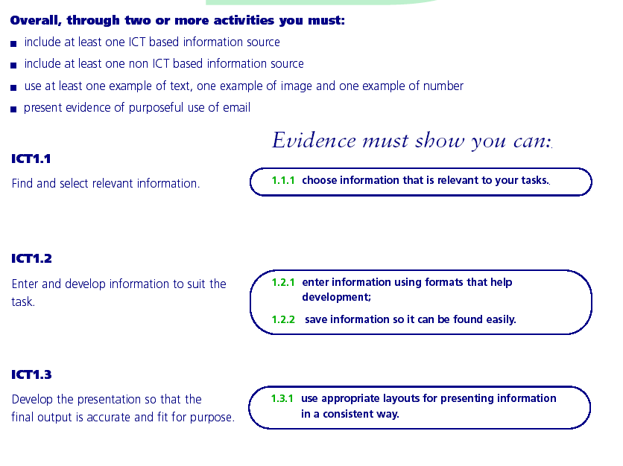
ICT1
Information Communication Technology

ICT Key skills Level 1

If completed correctly this assignment will enable you to achieve the standards for Key skills Information Communication Technology Level 1. Please refer to the standards.

Project

- You are set the challenge of organising an event. This could be an educational trip, a wedding, a night out for a group of students, etc.

Task 1

Your first task is to brainstorm with a partner to find all the important things required and put them in order of priority.

Task 2
(ICT 1.1, 1.2)

Design the invitation ensuring that it contains all relevant information. You must hold onto all draft copies to ensure you have evidence of development. Show it to a friend to obtain their opinion of it – they may suggest some worthwhile improvement. You must also remember to email a copy to your tutor. You may use any appropriate application.

Task 3
(ICT 1.1, 1.2)

- Collect contact information for businesses (suppliers) you will use in the process of organising the event and store this information in a database.
- Use your database to find all the suppliers of flower.
- Choose two of the suppliers and find the cost of flowers for the occasion.
You will need to use the internet as well as paper-based resources (e.g. books and/or magazines)

Task 4
(ICT 1.1, 1.2, 1.3)

Work out the cost of organising the event using an appropriate computer application to calculate and display the breakdown of cost. Your final printout should be an invoice or quotation, with your logo on it. Remember that you must also produce a printout of the formulas used.

Plan it

Do it

Edit & Develop it

Document it

ASSIGNMENT CHECKLIST

Please use this checklist to make sure you include everything you need in your assignment.

ICT 1.1
Prints of ICT search results (eg page from Google)

Print of relevant ICT research

Copy of non-ICT research (relevant information may be highlighted)

ICT 1.2
Draft copies showing how text has been entered and developed (eg tabs & tables)
Draft copies showing how numbers have been entered and developed (eg format of numbers, formulae)
Draft copies showing how images have been entered and developed (eg image imported & moved or resized)

ICT 1.3
Final (spellchecked & proofread) copies showing text presented in a suitable, consistent and clear way
Final (spellchecked & proofread) copies showing number presented in a suitable, consistent and clear way
Final (spellchecked & proofread) copies showing images presented in a suitable, consistent and clear way

E-mail
Prints of e-mails

Proof of saving work
Screen prints of saved files

ALSO, DON’T FORGET TO CHECK YOU HAVE:

- ANSWERED THE QUESTION IN FULL
- NUMBERED EACH PAGE
- NAMED EACH PAGE

